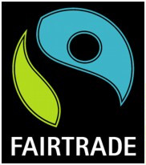
Kenilworth Fairtrade Town Trail
15 shops and businesses in Kenilworth have posters in their windows of a Fairtrade product they use or sell. Simply solve the clues, find the poster and write down the product. The first 12 are all in walking distance of the clock tower. Complete these to enter the draw to win a hamper of Fairtrade products from Sainsbury’s. Solve the bonus 3 questions to go in the draw for an extra prize.
 | Clue to find the poster | Product on the poster
1 | Jamie Oliver shops here
2 | Get away in Abbey End
3 | I do more plum (anag) for health products
4 | Sponsors of the premier league
5 | Stir china (anag) hair and beauty
6 | A hot season, where crops grow
7 | Boy trod oh (anag) sells houses
8 | Take your time buying a book
9 | Read all about it every Friday
10 | An item for that certain occasion in Talisman Square
11 | For pets on the way to the train
12 | “Dancing Queen” singers hobby
 | BONUS QUESTIONS
1 | Money advice on the way to swim
2 | A royal visitor and a Kenilworth landmark
3 | Mediterranean tree in Albion St
Put your completed form in the posting box in the entrance to Sainsbury’s before 9 March for a chance to win a prize.
Name Phone

Choose products with the Fairtrade mark

